Tab 1
Dec 4, 2025
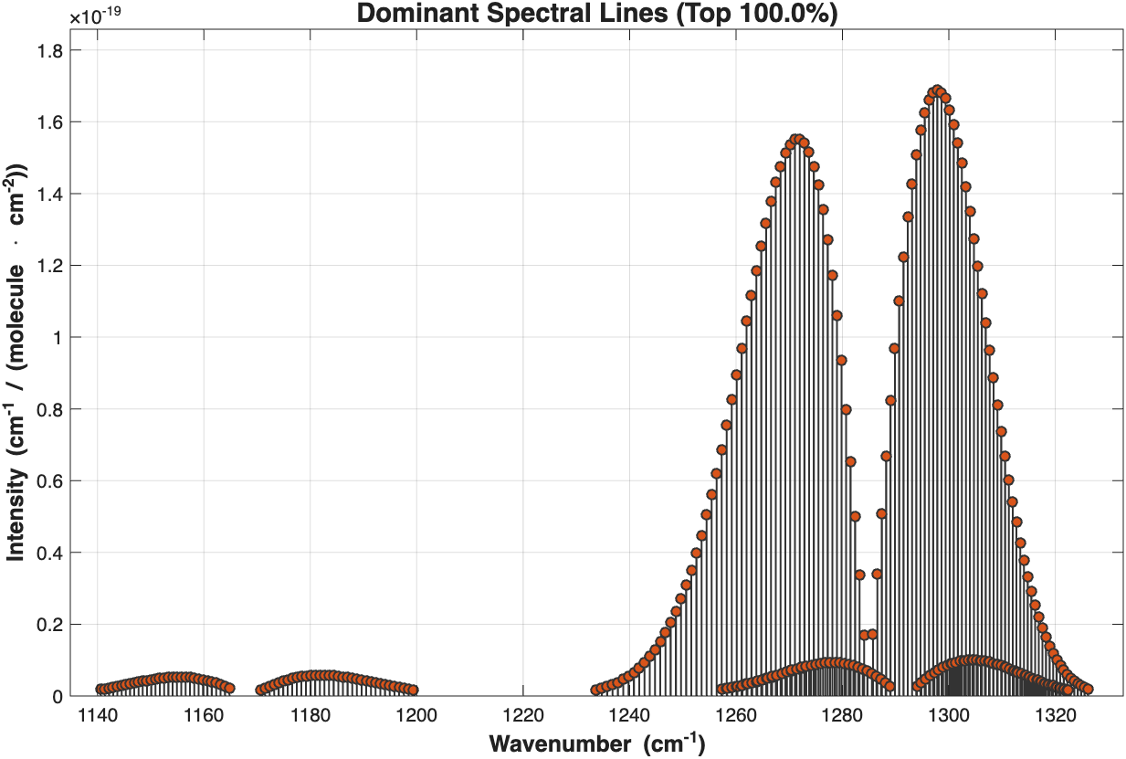
Figure 1: N2O absorption spectrum from HITRAN database (Gordon et al., 2021).

Resonance frequency of the ADM01 is detected as f_0=12458.8 Hz.

Gas delivery set-up consists of two mass flow controllers, ALICAT MC-10SCCM-D and ALICAT MC-200-SCCM-D/5M which controls the input flow to the system. First MFC supports the flow up to 10 SCCM, used to deliver gas to be detected to control small amounts, which is N2O for our application. The second is configured to deliver N2 as a buffer gas to set desired concentration. Output of the two MFC coupled and delivered to a pressure controller, ALICAT PCD-15PSIA-D-PCV50/5P, used to control pressure in the ADM01 and supports pressure up to 15 PSIA. It has two outputs, one is connected to the ADM to control pressure in a closed chamber, the other is connected to a pump to remove excess gas out of the system, Vacuubrand MZ-2C-NT. The pump output connected to the fume hood.

Daylight Solutions MIRcat-2300 quantum cascade laser (QCL) used as excitation source for experiment. The laser is capable of producing wavelengths between 1111-2000 cm^-1 (5-9 µm). Laser beam output from the QCL steered with two gold coated mirrors into ADM. Output power of the laser measured with OPHIR NOVA II powermeter. To extract low-amplitude signal from ADM lock-in amplifier put into use, EG&G 5110. Reference signal output taken from QCL’s TRIG OUT BNC port from the rear panel. A waveform generator RIGOL DG922 PRO (WFG) used to drive the QCL in desired frequency. Driving frequency set to f_0=12458.8 Hz for the operation.

For the first attempt, TRIG IN connected to the WFG with 50Ω coupling, V_pp=5.750V and f=f_0=12458.8 Hz. In the PC control panel, Laser Settings->Pulse Modes->Use External Trigger Mode is selected. Pulse width set to 1000 ns. Output wavelength set to 1297.8 cm^-1 to excite corresponding absorption bands of N2O in the spectrum. Laser output power for this configuration is measured as 20 mW. Input gas flow for N2O is set to 5 sccm, pressure level for the ADM is set to 500 Torr by using PCD. The operation conducted as a closed chamber, ADM output valve is closed for this purpose. No N2 is used for the first operation, so the concentration of the N2O in the ADM module is equal to 100 ppm. To perform photoacoustic detection of the N2O, ADM’s electrical connections were established. +12V (RED), -12V (BLUE) and GND (BLACK) to the KEYSIGHT E361A DC (PSU) power supply and set the output voltages as required levels for preamplification of ADM. Signal output (GREEN) of the ADM connected to a BNC cable, ground coupled to the common ground of PSU’s ground and signal to the signal port of the BNC with DC coupling and connected to lock-in amplifier’s A input channel. Finally, the gas flow is opened and the lock-in amplifier set to Auto Measure mode, which automatically detects the required sensitivity level.

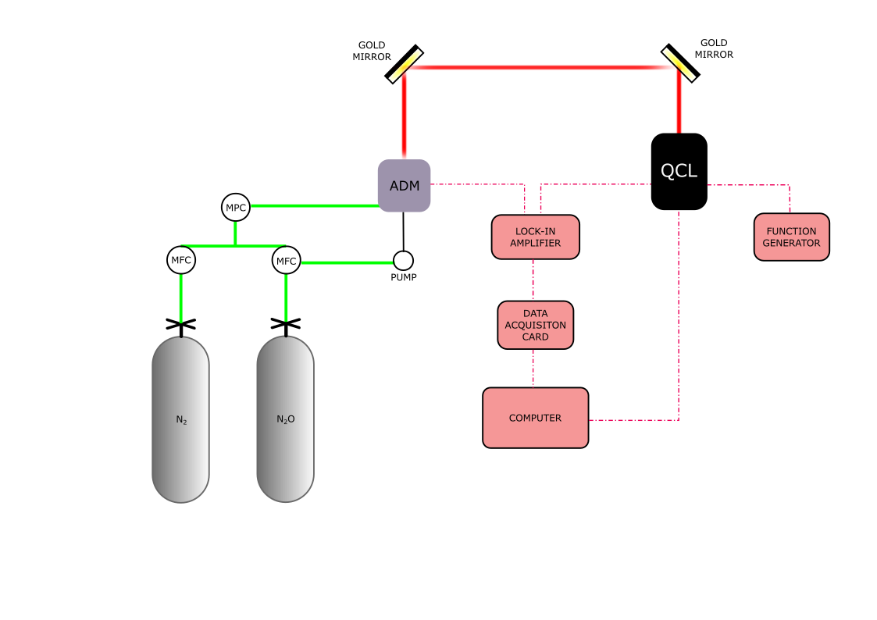
Figure 2: QEPAS setup schematic.

Display 2 of the lock-in amplifier set to %FS RΘ mode, which first display shows the amplitude of the detected signal at reference frequency and second display shows the phase information. Sensitivity is set to 20 mV automatically and a photoacoustic signal is detected in the first display, which shows 12 mV. To be sure laser output closed&opened, gas flow closed/opened and tested if we get any signal in closed configuration and there’s no signal appearing on the lock-in amplifier. As a conclusion we can conclude that we successfully detected the 100 ppm N2O with ADM, at 1297.8 cm^-1.
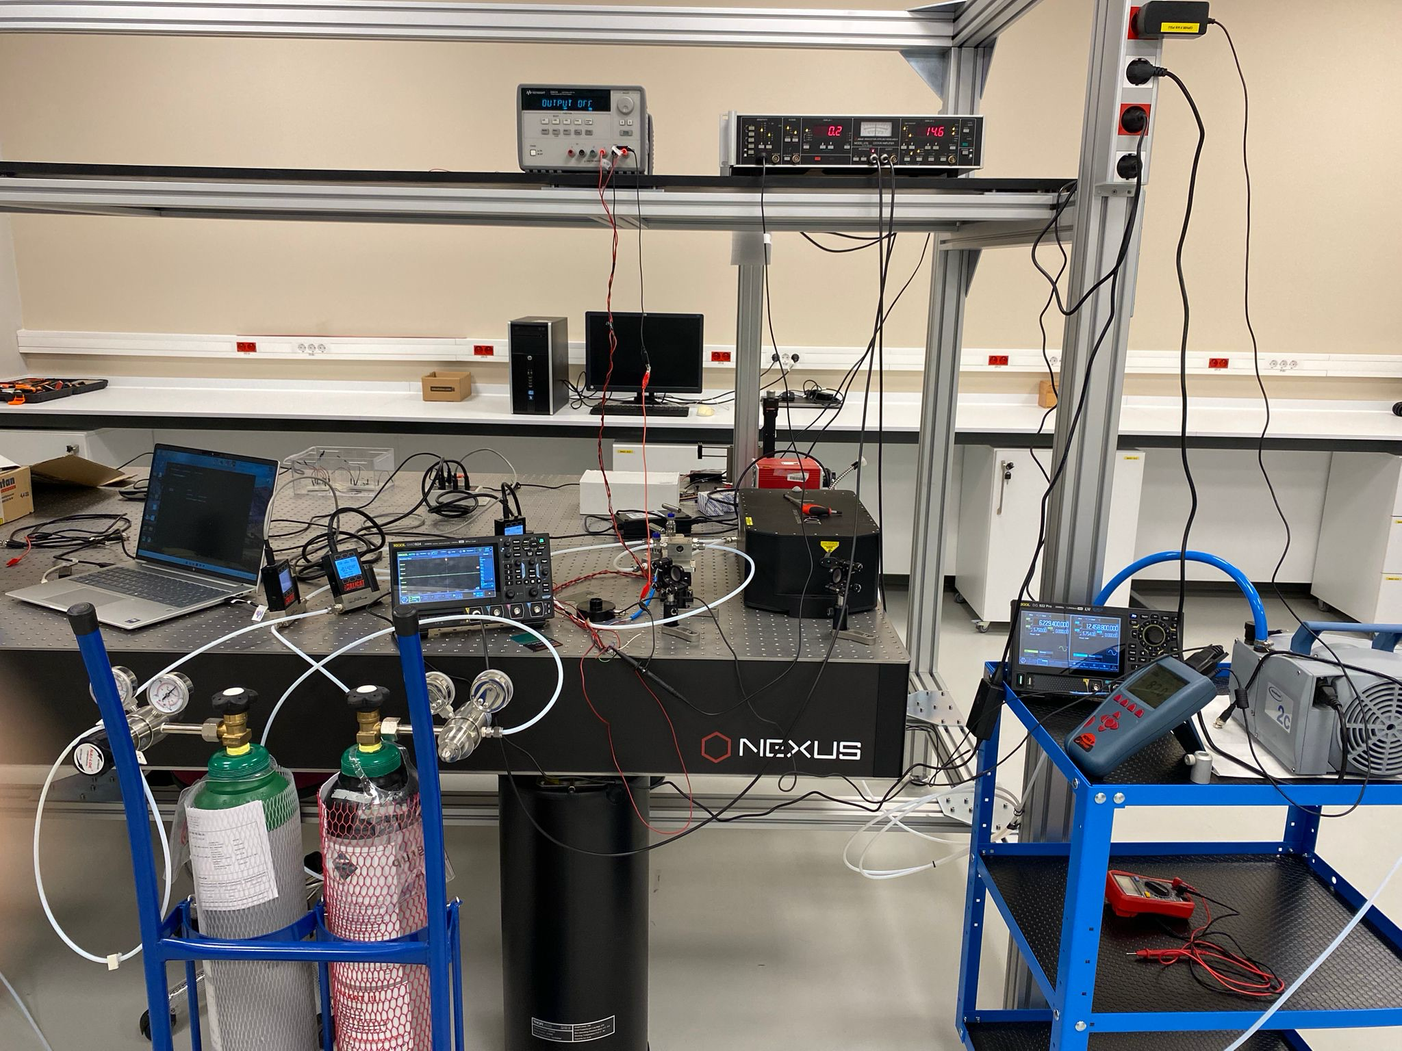
Figure 3: QEPAS setup.

Dec 11, 2025
We tried to find different absorption peaks of the N2O. For this reason, we used the HITRAN database as previously stated. Laser parameters set as following: f_rep=f_0, pulse width pw=800 ns. This resulted in different power levels for different wavelengths. Gas delivery configured as follows: N2O flow rate set to 10 sccm, no flow taken from N2 initially. Chamber pressure was set as 600 Torr, and we operated in a closed batch. The two main absorption peaks of 1297.8 and 1271.5 cm-1 set and yielded 22 mW and 19 mW average power, respectively. We read 28 and 31 in display 1 %FS RΘ mode in 50 mV sensitivity setting, which corresponds to 14 mV and 15.5 mV real output signal.
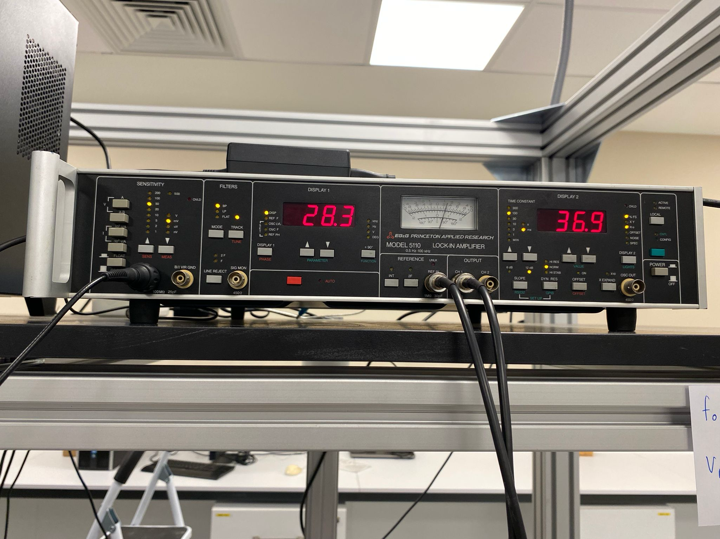
Figure 4: Lock-in amplifier data for 1297.8.

To tune our system and be sure that we’re detecting N2O, we tried to take data where reportedly zero absorption, around 1400 cm-1. However, we detect strong signals around 1400 cm-1 and attempted to find which absorption peaks our sample has. For this purpose, we used the scanning utility of our QCL and observed how the output signal reacts as the wavelength changes. We found strong peaks at 1456.9, 1405.2, 1288.5, 1287.5cm-1; 15.0, 29.0, 23.0, 28.3 mV, respectively. We tried to figure out which substance has these absorption peaks that yield a strong photoacoustic signal, which we found out as H2O, water vapour.
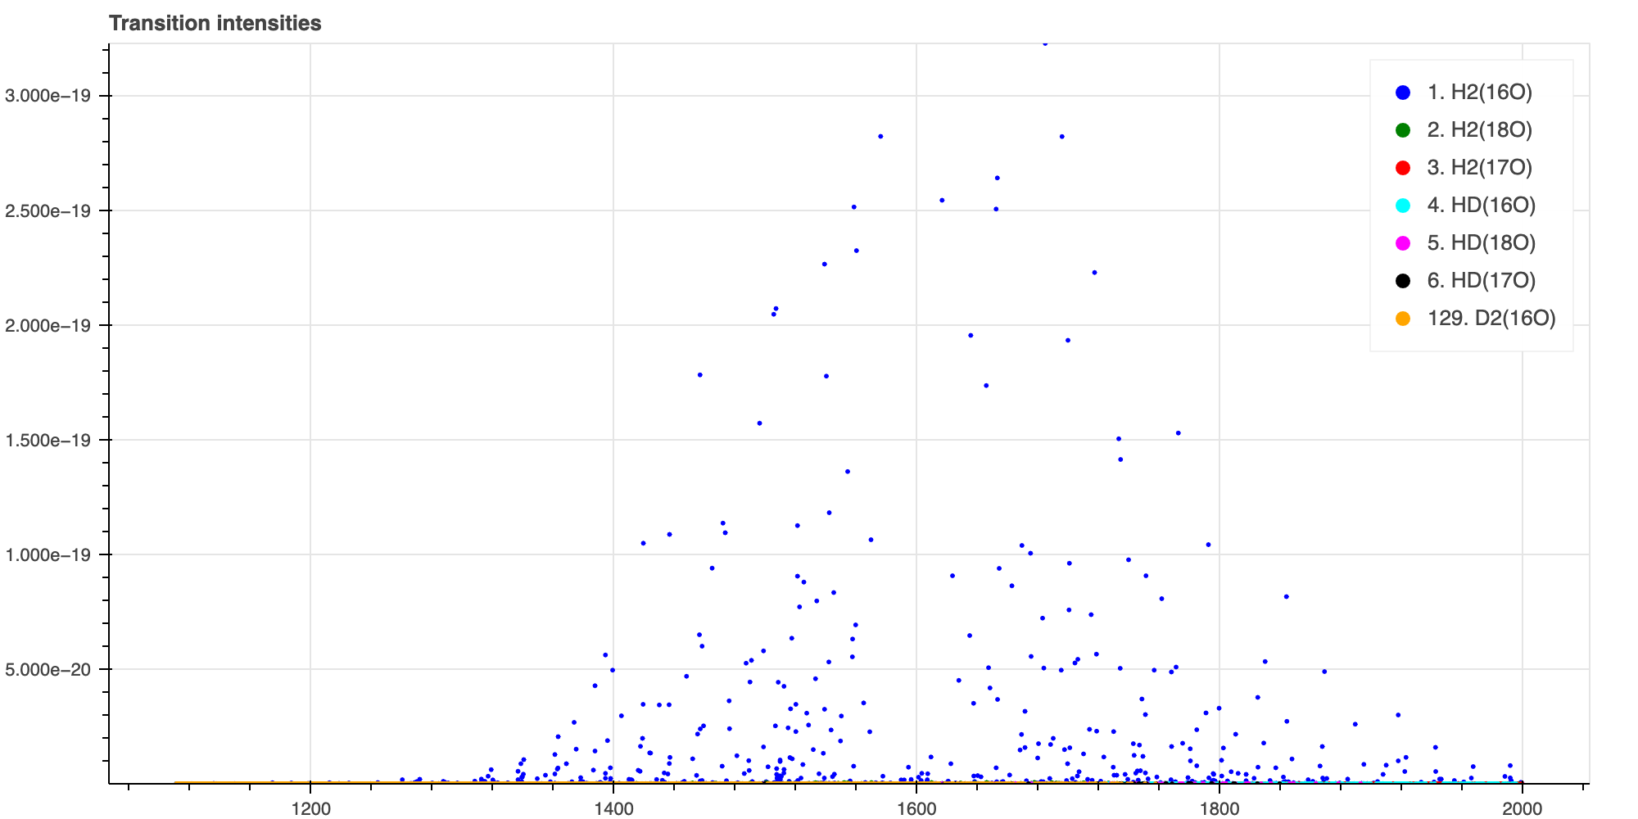
Figure 5: H2O absorption spectrum from the HITRAN database between 1111-2000 cm-1 (Gordon et al., 2021).
We append the recorded absorption peaks to H2O, which is most likely to be present in our ADM. We also check N2 spectrum, which constitutes the major part of the air, but it also has no absorption at 1456.9, 1405.2, 1288.5, 1287.5 cm-1 and shows almost no absorption for our QCL spectrum, which can be seen from Figure 6.
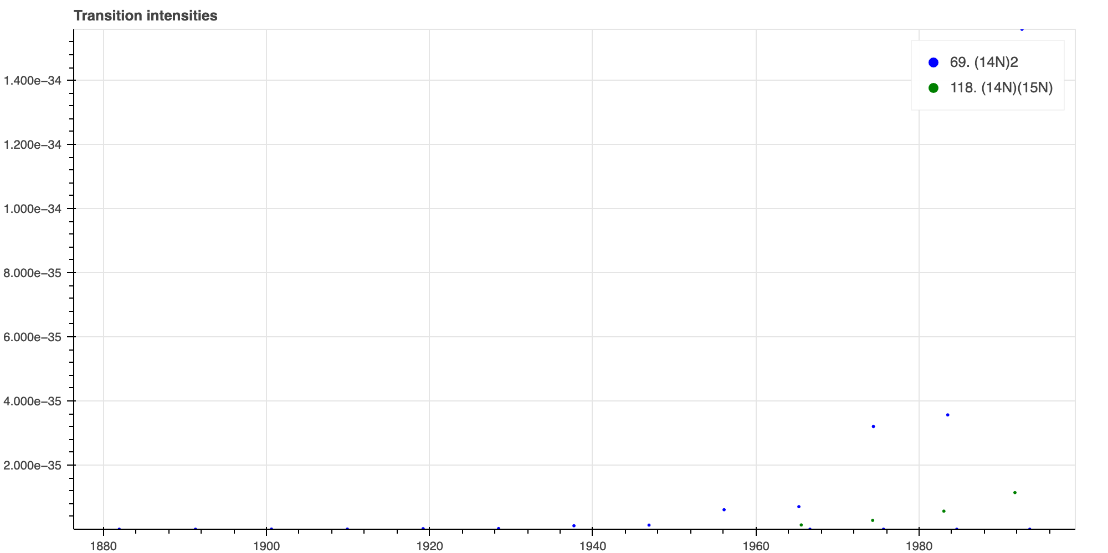
Figure 6: N2 absorption spectrum from the HITRAN database between 1111-2000 cm-1 (Gordon et al., 2021).

To be sure and characterise H2O spectrum further, we attempted to scan all absorption peaks of the H2O. For this reason, we also scanned the wavelengths around 1600 cm-1, corresponding to 6.2 µm has low output power for our QCL system. For this reason, we couldn’t record the peaks near this wavelength. We tried to record wavelengths near 1800 cm-1. 1798.5 and 1772.7 cm-1 also showed 16 and 20 mV signal output respectively. These results lead us to conclude that we’re detecting water vapour present in our system. As a next step, we we will try to record lock-in data simultaneously with tuned wavelength to get full spectrum for our sample in ADM. Another challenge is to remove H2O from our system or to learn how to treat this issue.

Final remarks
We find out some phenomenon that affects the experiment results but we did not systematically examined how this changes which stays as a future challenge to be explored. The pressure set in the ADM looks like linearly affects the output signal strength, which increases with increasing chamber absolute pressure.

We also tried to remove all the water vapour and other contaminant gases from our system, for that purpose we opened the dead end of the ADM, which allows the extraction of the input gas by directly connecting our ADM output to the vacuum pump. In the meantime, we increased the N2 input to pass it from the chamber and wipe out what’s inside the chamber. This reduced chamber pressure to the 60-70 Torr. With this way we achieved to zero-out our readings from the lock-in. But this might occurred due to lack of pressure in the chamber or we might’ve removed all the air inside the chamber by creating a vacuum effect. This should be explored further.
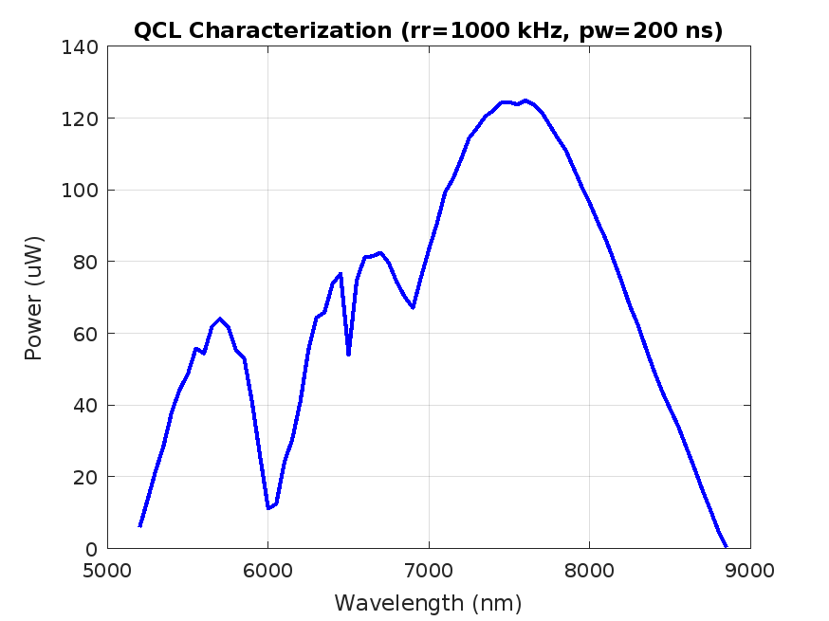
Figure 7: QCL characterization.

References

- Gordon, I., Rothman, L., Hargreaves, R., Hashemi, R., Karlovets, E., Skinner, F., Conway, E., Hill, C., Kochanov, R., Tan, Y., Wcisło, P., Finenko, A., Nelson, K., Bernath, P., Birk, M., Boudon, V., Campargue, A., Chance, K., Coustenis, A., . . . Yurchenko, S. (2021). The HITRAN2020 molecular spectroscopic database. Journal of Quantitative Spectroscopy and Radiative Transfer, 277, 107949. https://doi.org/10.1016/j.jqsrt.2021.107949

